Analysis Model

  - Use Case Diagrams
This section provides a detailed description of the use case diagram from the system. The whole system can be divided into two subsystems: Mobile Application and Web Portal. The first subsystem has the Mobile user as the main actor and the second one has the Administrator and Restaurant Owner as its main actors. Fig.4-1 and Fig.4-2 depicts the subsystems, respectively.
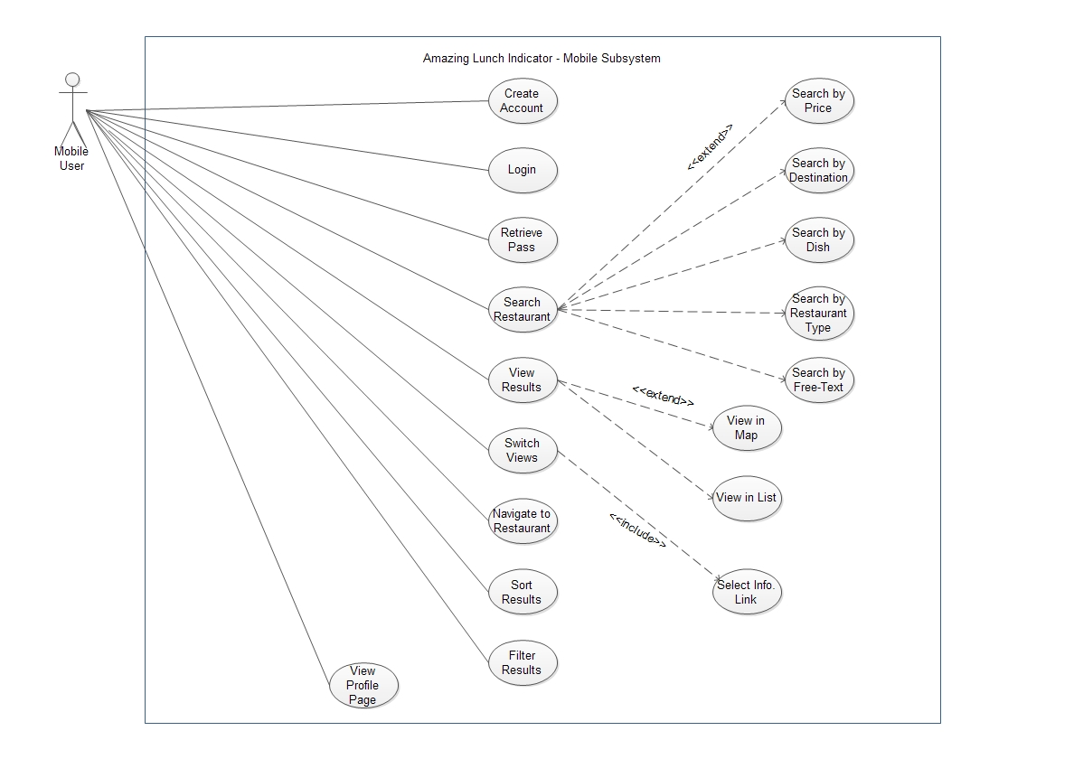
Figure 1: The Mobile application subsystem use cases
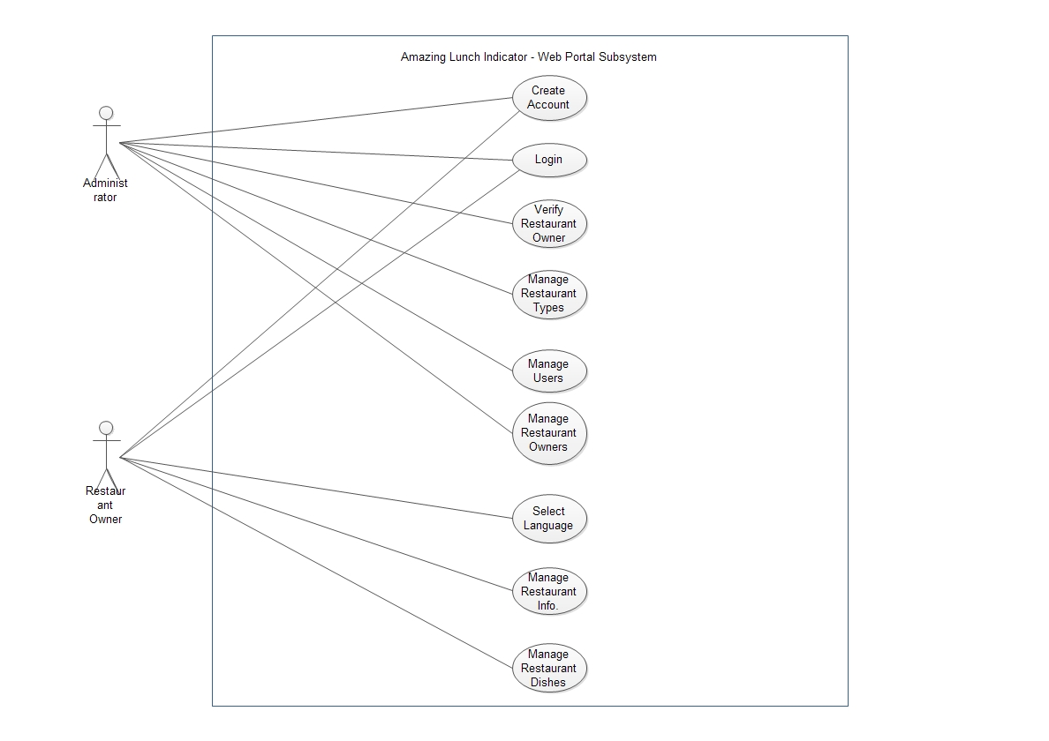
Figure 2: The Web portal subsystem use cases

